 

***I***n a joint effort to create awareness with regards to child protection week, various role players got together to highlight the importance of safety and child protection. This event took place at the Blue Route Mall on the 8th June 2019. Kirstenhof SAPS, Kirstenhof CPF, Fidelity ADT, various neighbourhood watches, VEP and Blue Route Mall arranged this fun filled event for the kids. Various activities took place with the highlight being the magical tricks from Mr FADT while the kids were taught about safety. There were lots of competitions for young and old, with fabulous prizes to be won, which were kindly sponsored by FADT.

Kirstenhof SAPS, with the help from their victim support team, fingerprinted over **200** kids that day. These forms are then completed by the parents and sent home with them for safe keeping in case their child goes missing. The children were treated to something sweet after the completion of the fingerprints and for those children who felt a little overwhelmed, being coaxed and cuddled by the officer saved the day! This is an on-going project and schools and preschools are welcome to call Kirstenhof SAPS to set up a day for fingerprinting. On display were also various pamphlets regarding substance abuse, domestic violence and how to become a reservist in SAPS. The counsellors from the victim support room were on hand to assist with the free services they offer from the station. The officers on duty also answered any questions the public had with regards to various concerns and were advised the best way possible.

Although the SAPS continues to deploy police officers to patrol the streets in order to maintain visibility and combat crime as part of an intensified drive against criminal activities, the fact that most perpetrators are in close proximity to their child victims often makes it difficult for the police to protect or prevent criminal acts perpetrated against them. Investigations can then only be carried out after the child has been victimised.

Therefore, SAPS need the help of community members, because crime is committed mostly by people known by the community. In most cases the perpetrators are known to their victims or are related to them. With the help of the community we can put those perpetrators, who take advantage of vulnerable children, behind bars

**If you suspect that abuse is taking place please do not keep it quiet, report it to your nearest police station or the SAPS crime stop number 0800 10111. You may remain anonymous and all information will be treated with the strictest confidence and sensitivity.** Sgt Solomon









Kirstenhof CPF Newsletter

June 2019

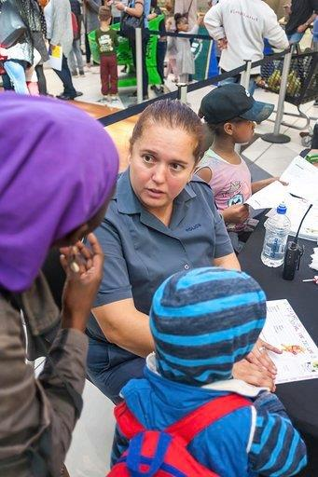

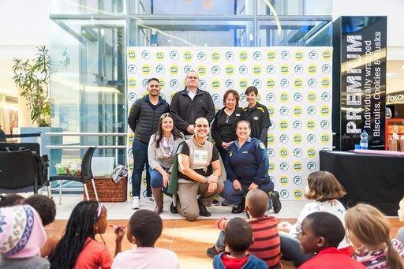

Pictured: Fidelity ADT

Kirstenhof CPF

Local neighbourhood watch

Kirstenhof SAPS

Sgt Muller assisting a member of the community

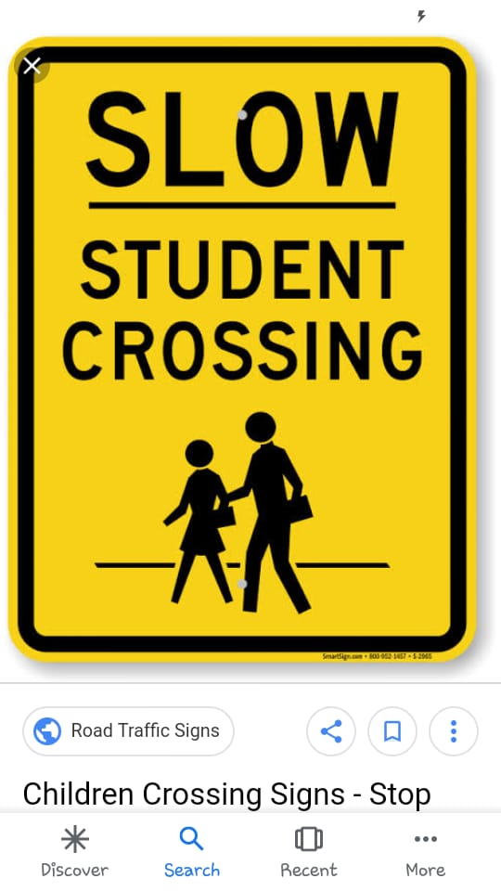

**K**irstenhof SAPS and Kirstenhof CPF’s on-going focus is the safety of scholars before, during and after school. As part of the safer school’s program, regular meetings are held with the management of the schools, SAPS safety officer and CPF school officer to address concerns they might have, and which can to be addressed by SAPS.

As the sun rises later in the morning it is still quite dark when the children are being dropped off at school. Some schools do not have sufficient street lighting or scholar patrols at the drop off points, which makes it difficult for other motorists to see the children.

Motorists are asked to please take extra caution in the vicinities of schools and to obey the road traffic rules. Traffic Police will also be of assistance where possible going forward.

Sgt Solomon

Kirstenhof Visible Policing Commander:

Captain E. Jones

Captain Jones started his policing career in 1987,

dedicating 32 years to serving and protecting the

community. He was promoted to Captain in 2000 as the

head of the Visible Police at Kirstenhof. A role he finds challenging yet rewarding at times. Over the years he has implemented various strategies in addressing crime and always encourages his members working under him to strive to do their best and to remain positive even in the toughest of times. An officer that is well known in the community and respected by his fellow peers for his commitment and hard work in making sure that service delivery is of the highest standards at Kirstenhof. He motivates his members to study further and to take their policing career in different directions. This saw some of the members venture off to various units within the police where they now excel. Proud moments for the commander indeed. Currently he is the commander of 27 visible members who are divided into 4 shifts with each shift having a shift commander. Currently 2 of the shift commanders are females which in a male dominated service, Captain Jones encourages. So, working under a female station commander does not matter to Captain Jones and he supports her in running the station. Although Kirstenhof still struggles with manpower, this office does not hesitate to pull a double shift to make sure that service delivery is not hampered. With the continued support of the community and the dedicated patrollers assisting with bringing the crime down, Kirstenhof SAPS will continue to be one of the best stations in the cluster. Sgt Solomon

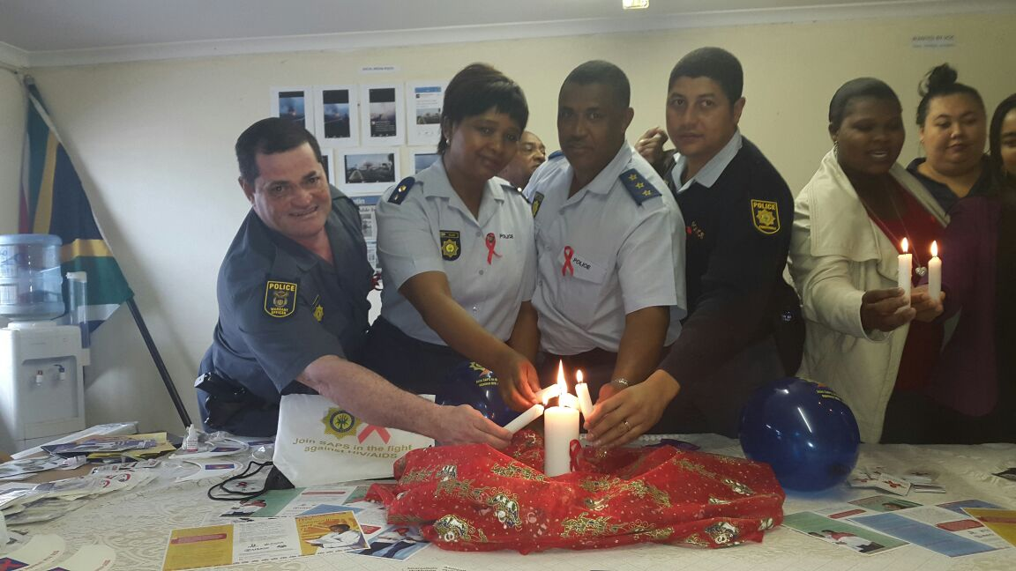

Complaints and compliments

Various surveys were conducted via telephone, emails and one on one interviews to measure service delivery at Kirstenhof SAPS. A total of 45 people were surveyed and everyone was happy with the service received.

Success for june

Intensified police visibility in the Kirstenhof area and ongoing tracing operations by the Kirstenhof detective branch, repeatedly results in remarkable successes. The following arrests were executed for the month of June.

Housebreaking and theft: 3

Assaults: 10 Wanted persons: 2

Possession of drugs: 2 Drunk driving: 6

Shoplifting: 7

Theft of motor vehicle: 5 Sgt Solomon

 

**Teach your children about Internet safety**

With the school holidays here, children will spend more time on their devices and the internet. Teach your kids how to practise Internet safety, to learn the benefits and also to realise the dangers of the internet, make them aware about online.

**What is cyber bullying?**

Occurs when a child or teen uses the internet, emails, text messages, instant messaging, social media, and online chat rooms to harass, threaten or humiliate another child or teen. Cyber bullies come in all shapes and sizes. The methods used for cyber bullying ranges from sending taunting messages, breaking into your email account or stealing your online identity. Some might even create a website or media page to taunt you.

**Tips for children/teens dealing with cyber bullying**

Do not respond. Do not retaliate. Save the evidence. Block the bully. Reach out for help.

**Spot the warning signs**

Becomes distressed during or after using the internet or cell phone. Appears anxious when receiving a text or email. Avoids discussions or is secretive about computer activities. Withdraws from family and friends and refuses to go to school. A change in behaviour, moods, sleep, or shows signs of depression.

**Prevent cyber bullying, teach your children to:-**

Never post or share their personal information online including full names, telephone numbers, address, school name and credit card numbers. Never share your internet password. Not to post anything online that they would not want classmates to see. Once it is posted it is out there forever. Deleting it from your device does not mean that it is no longer on the internet.

**Monitor your child’s technology use:**

Regardless of how much your child will resent it, you can only protect them by monitoring what they do online. Keep the computer in a busy area in the house so that you can easily monitor its use. Set up filters on the computer. Tracking software can block inappropriate web content and can help you check your child’s online activities. Insist on knowing your child’s password.

**Tips for parents dealing with cyber bullying**

Educate your child as your child may not know how harmful or damaging their behaviour can be. Remind your child that cyber bullying can have very serious legal consequences. Let your child know that you will be monitoring their use on the internet. Establish consistent rules of behaviour**. Debra Wucherpfennig, volunteer counsellor at Kirstenhof SAPS is available for talks on the Dangers of Social Media to schools for their LO classes and parent evenings. Phone 021 712 6699.** Sgt Solomon

#Internet Safety

**URGENT NOTICE!!!!!NEW LANDLINE NUMBERS AT KIRSTENHOF SAPS**

Please note the new landline numbers for Kirstenhof SAPS CSC : **021-7029122 or 021-7029123**

For any service delivery complaints please contact **Captain Jones on 082 469 2941**